**Name: PARMESH YADAV**

**Roll No: 2020319**

MTH-372 SI

ASSIGNMENT- 2

QUESTION – 1

According to the question,

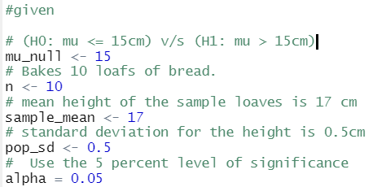The claim was: “**baker claims that his bread height is more than 15 cm, on the average**”

Therefore, **H0: μ <= 15 v/s H1: μ > 15**

**Assumptions:**

* Simple Random Sample.
* σ is known.
* The distribution is Normal.

Since, all the assumption for Z-test have been satisfied, we calculate Zstat.

**Zstat = (sample_mean - mu_null)/(pop_sd/sqrt(n))**

Which comes out to be = **12.6491106735**

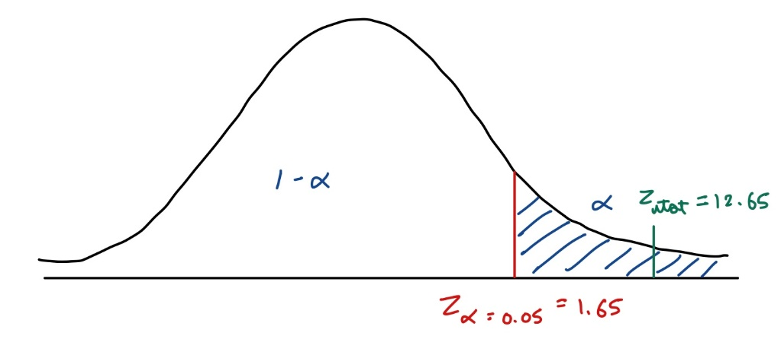The critical value is then calculated for **α = 0.05** since this is **one tailed,**

**Zalpha = 1.64485362695147**

Also,

**p_value = 5.65 x 10-37**

**p-value < alpha (0.05)**

**Result and Inference:** Since the **test statistic lies in the rejections region**, we, therefore, **reject the null hypothesis**. This means **that H1 is true**. Therefore, **the baker’s claim** that his bread height is more than 15 cm, on the average, **is in fact TRUE.**

QUESTION – 2

According to the question,

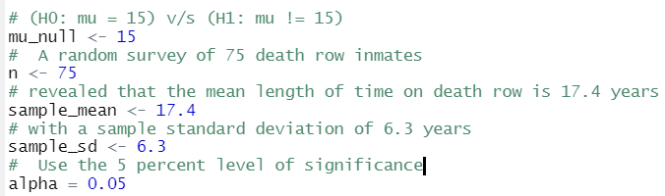

The claim was: **“population mean time on death row could likely be 15 years.”**

Therefore, **H0: μ = 15 v/s H1: μ != 15**

**Assumptions:**

* Simple Random Sample.
* σ is unknown.
* S is known.
* n > 30

Since, all the assumption for T-test have been satisfied, we calculate Tstat.

**Tstat = (sample_mean - mu_null)/(sample_sd/sqrt(n))**

Which comes out to be = **3.29914439536929**

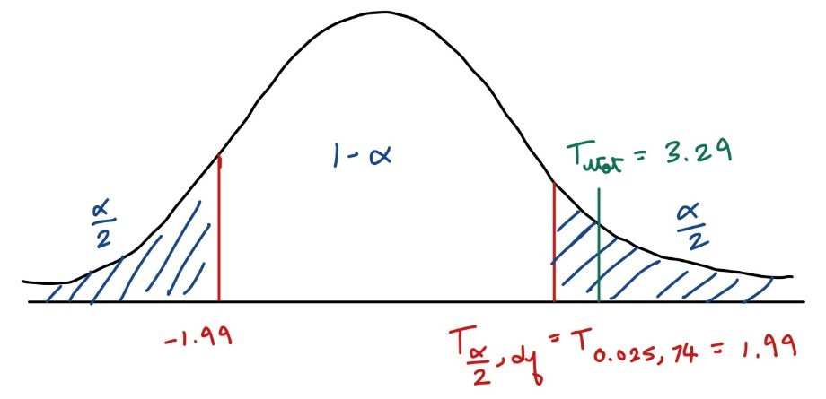The critical value is then calculated for **α/2 = 0.025 & df = 74(n-1)** since this is **two tailed,**

**Talpha/2 = 1.99254349518093**

Also,

**p_value = 0.0007**

**p-value < alpha (0.025)**

**Result and Inference:** Since the **test statistic lies in the rejections region**, we, therefore, **reject the null hypothesis**. This means that **H0 is not true**. Therefore, **claim** that population mean time on death row could likely be 15 years, **is in fact FALSE.**

QUESTION – 3

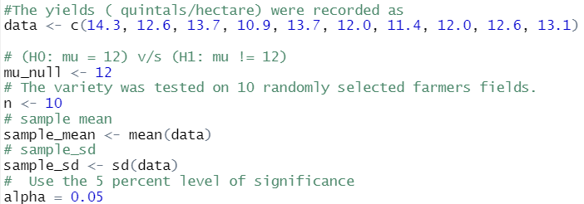According to the question,

The claim was: **“a new variety of green gram is expected to give a yield of 12.0 quintals per hectare.”**

Hence, **H0: μ = 12 v/s H1: μ != 12**

**Assumptions:**

* Simple Random Sample.
* σ is unknown.
* S is known.
* The distribution is normal.

Since, all the assumption for T-test have been satisfied, we calculate Tstat.

**Tstat = (sample_mean - mu_null)/(sample_sd/sqrt(n))**

Which comes out to be = **1.83564369493053**

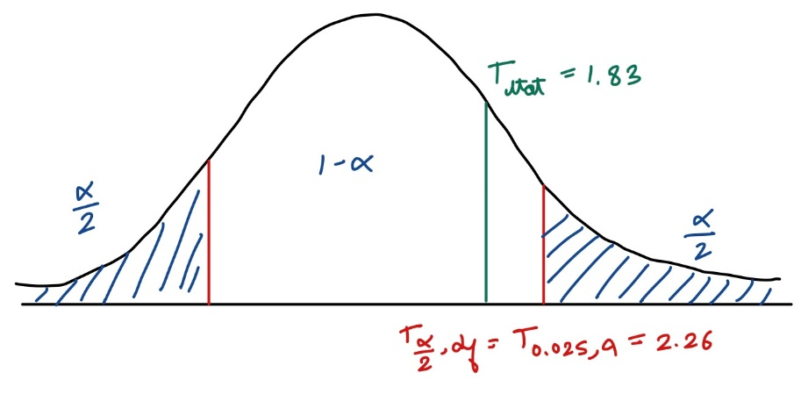The critical value is then calculated for **α/2 = 0.025 & df = 9(n-1)** since this is **two tailed,**

**Talpha/2 = 2.2621571627982**

Also,

**p_value = 0.049**

**p-value > alpha (0.025)**

**Result and Inference:** Since the **test statistic lies in the acceptance region**, we, therefore, **fail to reject the null hypothesis**. This means that **H0 is true**. Therefore, **claim** that a new variety of green gram is expected to give a yield of 12.0 quintals per hectare., **is in fact TRUE.**

QUESTION – 4

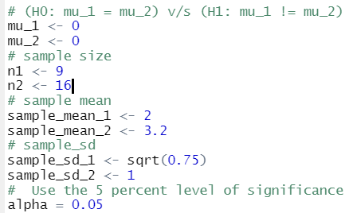According to the question,

The claim was: **“The average amount of time boys and girls ages 7 through 11 spend playing sports each day is believed to be the same.”**

Therefore, **H0: μ1 = μ2 v/s H1: μ1 != μ2**

**Assumptions:**

* Simple Random Sample.
* Both samples are independent of each other.
* σ1 , σ2 is unknown.
* S is known.
* The distribution is normal.

Since, all the assumption for T-test have been satisfied, we calculate Tstat.

**Tstat = ((sample_mean_1 - sample_mean_2) -(mu_1 - mu_2))/sqrt((sample_sd_1^2/n1)+(sample_sd_2^2/n2))**

Which comes out to be = **-3.14233761939829**

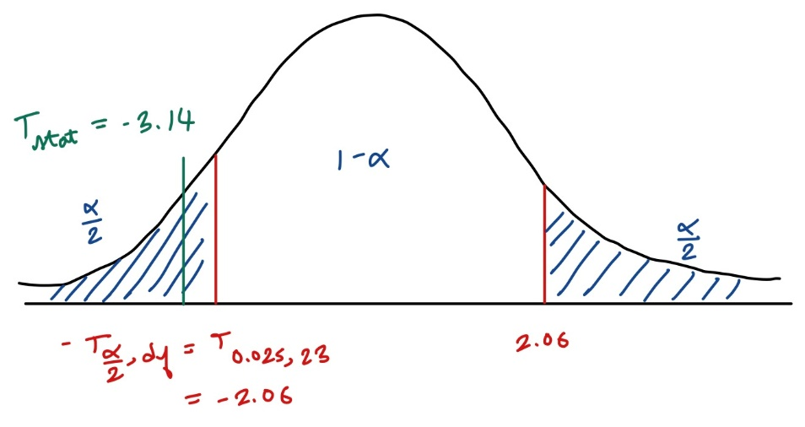The critical value is then calculated for **α/2 = 0.025** **& df = 23(n1 + n2 -2)** since this is **two tailed,**

**Talpha/2 = -2.30600413520417**

Also,

**p_value = 0.0068**

**p-value < alpha (0.025)**

**Result and Inference:** Since the **test statistic lies in the rejection region**, we, therefore, **reject the null hypothesis**. This means that **H0 is false**. Therefore, **claim** **t**he average amount of time boys and girls ages 7 through 11 spend playing sports each day is believed to be the same., **is in fact FALSE.**

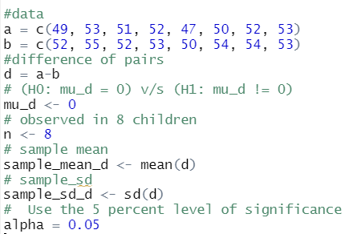QUESTION – 5

According to the question,

The claim was: **“there is any average change in weight of children due to Food B.”**

Therefore, **H0: μd = 0 v/s H1: μd != 0**

**Assumptions:**

* Simple Random Sample.
* Both samples are independent of each other.
* The distribution is normal.

Since, all the assumption for T-test have been satisfied, we calculate Tstat.

**Tstat = (sample_mean_d-mu_d)/(sample_sd_d/sqrt(n))**

Which comes out to be = **-4.32049379893857**

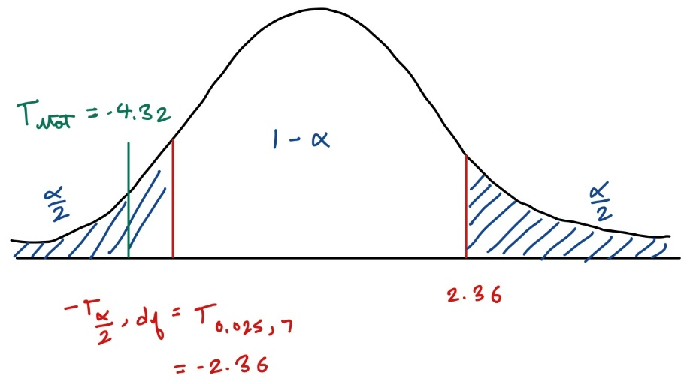The critical value is then calculated for **α/2 = 0.025 & df = 7(n - 1)** since this is **two tailed,**

**Talpha/2 = -2.36462425159278**

Also,

**p_value = 0.0017**

**p-value < alpha (0.025)**

**Result and Inference:** Since the **test statistic lies in the rejection region**, we, therefore, **reject the null hypothesis**. This means that **H0 is false**. Therefore, there is in fact an average change in weight of children due to food B.